What is Blackfacts?
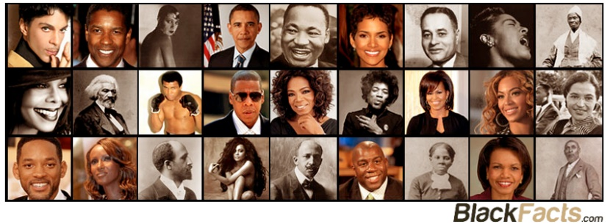
Started in 1997 as the Internet’s First Black History Encyclopedia, and today #1 on all Major Search Engines, Blackfacts.com is
“Creating the Future of Black History”
by:
1. Collecting Our Black History Stories Digitally,
2. Organizing Our Stories using Artificial Intelligence,
3. Publishing Our Stories to Any Device, and
4. Saving Our Stories Forever for all Future Generations.

Blackfacts is the 21st Century realization of W.E.B Dubois' lifelong dream project ‘Encyclopedia Africana,’ and is changing the power balance of Black History, for while libraries can burn, and all griots die, because we are storing Our Truth digitally, it will last forever, and because it is on a technology platform that WE Conceived, Created, Control and Own, this time around, for the first time in history, WE are in COMPLETE control of the narrative about Us.
Periodt.


For more information, contact:

Ken Granderson
Co-Founder/CTO



Blackfacts Brooklyn Office - Bed-Stuy, Brooklyn USA
Web: www.blackfacts.com
Email: ken@blackfacts.com
Phone: (857) 222-2318

