5 Things to Know about Blackfacts.com, the Internet’s First and Most Popular Searchable Black History Website

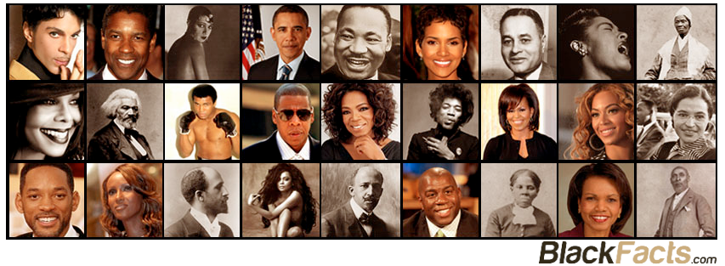

Blackfacts is Pioneering
Originally started in 1997 as a web site that showcased various events in Black History to present the internet as culturally relevant to people of African descent, BlackFacts.com (https://blackfacts.com) was the Internet’s first searchable Black History site, and today is realizing the lifelong dream of NAACP founder and international scholar W.E.B. DuBois that he called the ‘Encyclopedia Africana.’

Blackfacts is #1
The #1 search result on all the major search engines for ‘black facts', the BlackFacts web site serves millions of Black History facts to millions of site visitors each year, and every day, our almost 200K social media followers and email subscribers get our daily recommended dose of ‘Black Facts Of The Day™’ in their inboxes and social media feeds.

Blackfacts is Unique, Inspirational and OURS
BlackFacts is not only world-class technology that is ABOUT Black People, but was 100% Conceived, Created and Coded BY a Black Technologist - MIT Alumnus and Digital Pioneer Ken Granderson, who has been creating technologies designed to ‘Bring Communities of Color Into the Information Age’ since the dawn of the ‘Digital Divide.’

Blackfacts is Scalable and Disruptive
In a world where so much that happens online is done in the name of getting ‘Likes’ for the day, week or month, BlackFacts is driven by the BHAG (Big, Hairy Audacious Goal) of ‘Embracing Technology to Protect Your Culture’ and runs on the platform Ken built to:
- Host an unlimited number of virtual sites for members of various ethnic, professional, fraternal, faith or lifestyle groups to post their own history and achievements,
- Consume content from a variety of sources from online links to audio and video,
- Cross-reference the content using multiple AI engines, and ultimately
- Deliver it to groups and individuals subscribed to specific content channels on any present or future devices.

Blackfacts Needs YOU to Help Spread the Word
Blackfacts’ popularity and search engine ranking have all been 100% organic, based on our longevity and people sharing the site under the principle ‘Each One Teach One.’
In order for Blackfacts to realize its potential as the #1 go-to destination to find out anything about Black People, we ask you to visit the site at https://blackfacts.com, and if you like what you see, TELL SOMEBODY, and even better, create an account and then you can ADD A FACT to start the trend of telling OurStory!
Thanks to BlackFacts.com, we now have the ability to tell our own stories in the permanent medium of digital content, which is essential for future generations to know about, because


For more information, contact:

Ken Granderson
Co-Founder/CTO



Blackfacts Brooklyn Office - Bed-Stuy, Brooklyn USA
Web: www.blackfacts.com
Email: ken@blackfacts.com
Phone: (857) 222-2318
BlackFacts.com is a Service of Intellitech Consulting Enterprises, Inc (www.intellitech.net) all rights reserved.

1997 Capture of Blackfacts.com on the Wayback Machine - http://web.archive.org/web/19970413144554/http://www.blackfacts.com/
Google Example: https://www.google.com/search?q=black+facts (Paid Ads may be shown before organic search results, but are visibly marked as ‘Ad’)
As of 1/26/2020 – 96K Facebook follows at https://www.facebook.com/BlackFacts/, 74.6K Instagram followers at https://www.instagram.com/blackfactsonline/, 10.2K Twitter followers at https://twitter.com/blackfacts
Ken’s Digital History: http://www.kengranderson.com/. Ken is featured in “Black Software: The Internet & Racial Justice, from the AfroNet to Black Lives Matter” https://www.amazon.com/Black-Software-Internet-Justice-AfroNet/dp/0190863846
Lessons From Wakanda: Embrace Technology To Protect Your Culture, by Ken Granderson - https://www.linkedin.com/pulse/lessons-from-wakanda-embrace-technology-protect-your-ken-granderson/

