Help Protect the Future of Black History and Ethnic Studies This Holiday Season!
I’m Ken Granderson, a Bed-Stuy Brooklyn native and MIT Alumnus who has been using technology to tell the stories of underserved communities since 1995, and has been putting Black History online at https://blackfacts.com since 1997. You can learn about my work on my website https://kengranderson.com, in the book Black Software: The Internet & Racial Justice, from the AfroNet to Black Lives Matter, or by simply Googling my name.
As the holiday season approaches, I am reaching out to invite you to help safeguard our history, inspire our children, and empower educators across the nation. The “Protect Black History” campaign is your opportunity to make an immediate and lasting impact by sponsoring Diversity Schoolhouse by BlackFacts.com, my groundbreaking ed-tech platform for teaching Black History and Ethnic Studies in schools nationwide.

BlackFacts and Diversity Schoolhouse
BlackFacts.com is the Internet’s first and only continuously operating Black History search engine. Today, BlackFacts features over 1.5 million articles and over a dozen original video series including the Black Fact Of The Day™, a Black History video for every day of the year, as well as video series on LatinX, Caribbean, Native American and Asian American history makers.
Diversity Schoolhouse is a natural extension of BlackFacts’ mission that empowers K-12 educators with a unique ed-tech platform. With over 1,500 original videos, AI-driven tools, and semester-long courses, Diversity Schoolhouse enables teachers to teach Black History and Ethnic Studies from any internet-connected device. Currently in almost 100 schools across 14 states, including as a single-source vendor for New York City public schools, we deliver a 21st Century educational solution for our 21st Century students.

Black History Delivered on ANY Device |  | 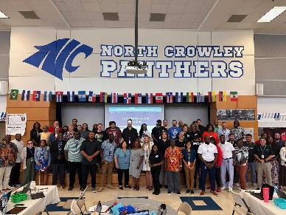  Professional Development Included
 | 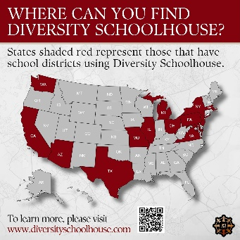 | 

Why Now?
The changing educational landscape, particularly with the potential implications of Project 2025, threatens vital public education programs. Grassroots-driven solutions like Diversity Schoolhouse are essential to ensure that Black History and Ethnic Studies remain accessible to students nationwide.
Thus, we are launching the ‘Protect Black History’ School Sponsorship Campaign.

The Campaign: Now to Year-End
Starting now and running through the end of the year, our campaign combines Small Business Saturday, Cyber Monday, and Giving Tuesday into one impactful initiative where your sponsorship dollars will put Black History and Ethnic studies in more schools via a unique software application created by a small, Black-owned business. Our campaign goal is to introduce Diversity Schoolhouse to schools across the country, ensuring educators have the tools they need to teach Black History and Ethnic Studies regardless of local or state budgets, or national trends.
Thanks to our partnership with Converge Mentor, a 501(c)(3) organization, your ‘Protect Black History’ sponsorships are 100% tax-deductible.

How You Can Help
Diversity Schoolhouse is a school-wide subscription that puts the ability to learn or teach Black History into the hands of the entire faculty at a cost similar to many one-day outings of just $2,000, for an entire calendar year. Two- and three-year subscriptions are discounted at $3,500 and $5,000, respectively. Sponsorship options include:
- Targeted School Sponsorships
Sponsor your own K-12 alma mater, your child’s school or multiple schools in your current or childhood neighborhood.
- Harambee (‘All pull together’) Sponsorships
Sponsorships of any size will be pooled to sponsor schools in underserved districts.
- Corporate Partnerships
Showcase your company’s commitment to diverse education by sponsoring multiple schools or an entire district. Branding opportunities include having your company name, colors and logo featured in Diversity Schoolhouse, recognition on our websites, and shoutouts to BlackFacts’ 200,000 social media followers on Facebook, Instagram, LinkedIn, Twitter and TikTok.

Do It Now!
- Learn more about Diversity Schoolhouse at https://links.diversityschoolhouse.com/intro.
- Schedule a demo to experience Diversity Schoolhouse: https://calendly.com/blackfacts.
- Make your sponsorship commitment today by contacting Ken directly at ken@blackfacts.com or 1-857-222-2318.
- SHARE THIS LINK with your personal or professional networks: https://documents.blackfacts.com/kengranderson/protect-black-history.pdf

Shaping the Future of Education
Support ‘Protect Black History’ and help us play a pivotal role in ensuring future generations of students have access to Black History and Ethnic Studies education, no matter where they are. Diversity Schoolhouse meets the challenges of the day head on, as the tip of the spear of BlackFacts’ mission to keep us in control of our narratives throughout the years to come.

We are on a Mission From Our Ancestors
To Protect the Future Of Black History
By Using Technology
That WE Created, Control and Own.
- Ken Granderson

Thank You for Protecting Black History with us,

Ken Granderson
Founder / Chief Technology Officer, BlackFacts.com
Architect and Developer, Diversity Schoolhouse
ken@blackfacts.com
1-857-222-2318

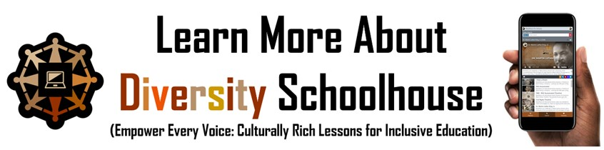
https://links.diversityschoolhouse.com/intro

